

Republic of the Philippines
CAVITE STATE UNIVERSITY
CvSU Bacoor City Campus
City of Bacoor, Cavite
(046) 476-5029
www.cvsu.edu.ph

DEPARTMENT OF COMPUTER STUDIES

FLOODSENSE INITIAL RESIDENT SURVEY RESULTS
The initial needs assessment involved 40 purposively selected qualified Bacoor City adults on October 11, 2026. Percentages describe these respondents, not all city residents. Checkbox percentages use all 40 respondents and may total more than 100%. This survey did not evaluate the application after use.
Consent and respondent eligibility
Q1. Have you read and understood the information above, and do you voluntarily agree to participate in this survey?
Q2. Are you 18 years old or older?
Q3. Do you currently reside in Bacoor City?
Q4. Within the past three years, have you experienced flooding or heavy rainfall that affected your household, community, travel, work, or studies?
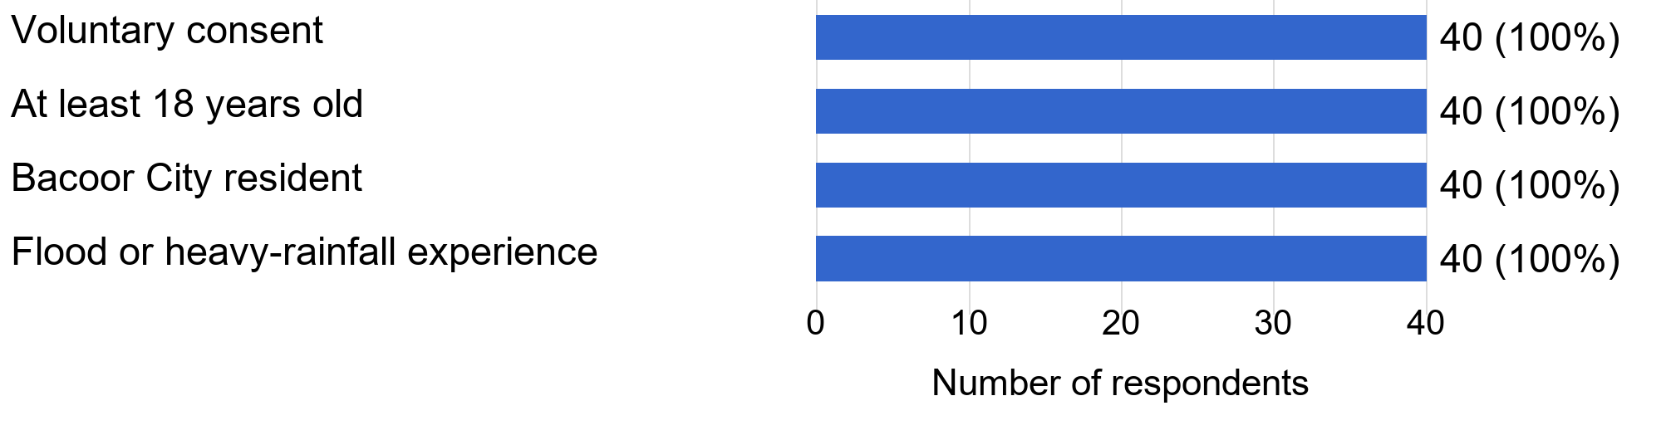
Figure 1. Consent and respondent eligibility (n = 40).
The four screening items established consent and eligibility. All 40 submitted records (100.0%) met each condition. These totals confirm the eligibility of the surveyed group, not the number of eligible residents throughout Bacoor City. The initial needs assessment collected responses on October 11, 2026; it did not ask participants to use or evaluate the application.
Republic of the Philippines
CAVITE STATE UNIVERSITY
CvSU Bacoor City Campus
City of Bacoor, Cavite
(046) 476-5029
www.cvsu.edu.ph

DEPARTMENT OF COMPUTER STUDIES

Barangay distribution
Question 6. Which barangay in Bacoor City do you currently reside in?
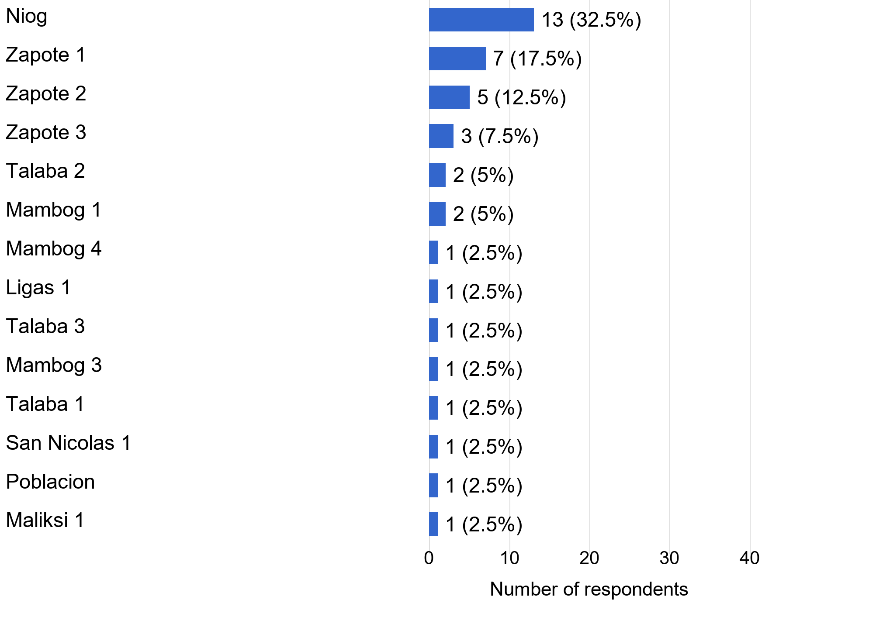
Figure 2. Barangay distribution (n = 40).
This single-response item recorded the respondents' barangays. Niog accounted for 13 of 40 respondents (32.5%). Zapote 1, Zapote 2, and Zapote 3 contributed 15 respondents (37.5%) together. The sample covered 14 barangays, with 28 respondents (70.0%) from Niog and the three Zapote barangays. This concentration limits geographic generalization beyond the surveyed group.
Republic of the Philippines
CAVITE STATE UNIVERSITY
CvSU Bacoor City Campus
City of Bacoor, Cavite
(046) 476-5029
www.cvsu.edu.ph

DEPARTMENT OF COMPUTER STUDIES

Age distribution
Question 7. What is your age group?
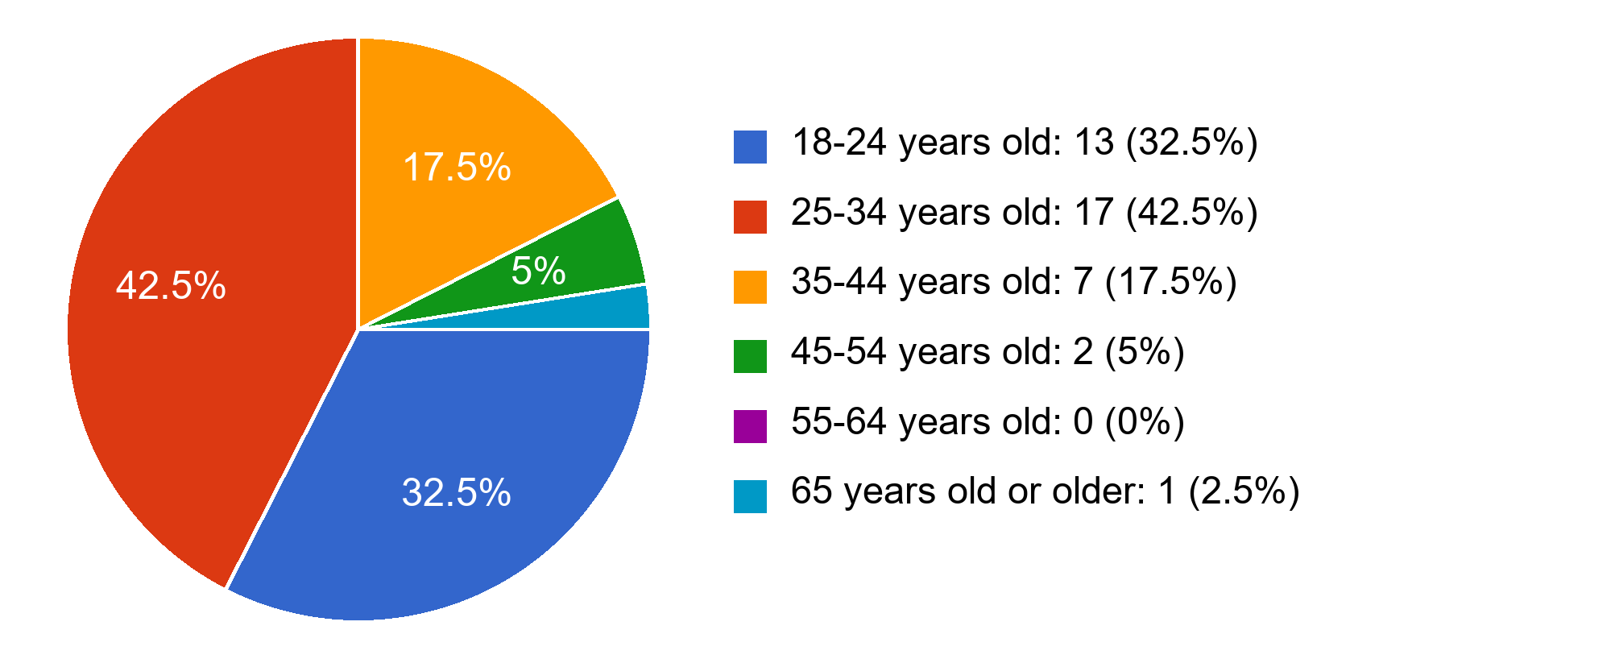
Figure 3. Age distribution (n = 40).
This single-response item described the age profile of the 40 respondents. The largest category was 25-34 years, with 17 respondents (42.5%), followed by 18-24 years, with 13 (32.5%). Together, these groups represented 30 respondents (75.0%). The concentration among younger adults means that the distribution should not be treated as the age profile of all Bacoor residents.
Republic of the Philippines
CAVITE STATE UNIVERSITY
CvSU Bacoor City Campus
City of Bacoor, Cavite
(046) 476-5029
www.cvsu.edu.ph

DEPARTMENT OF COMPUTER STUDIES

Reported effects of flooding and heavy rainfall
Question 8. How has flooding or heavy rainfall affected you within the past three years? Select all that apply.
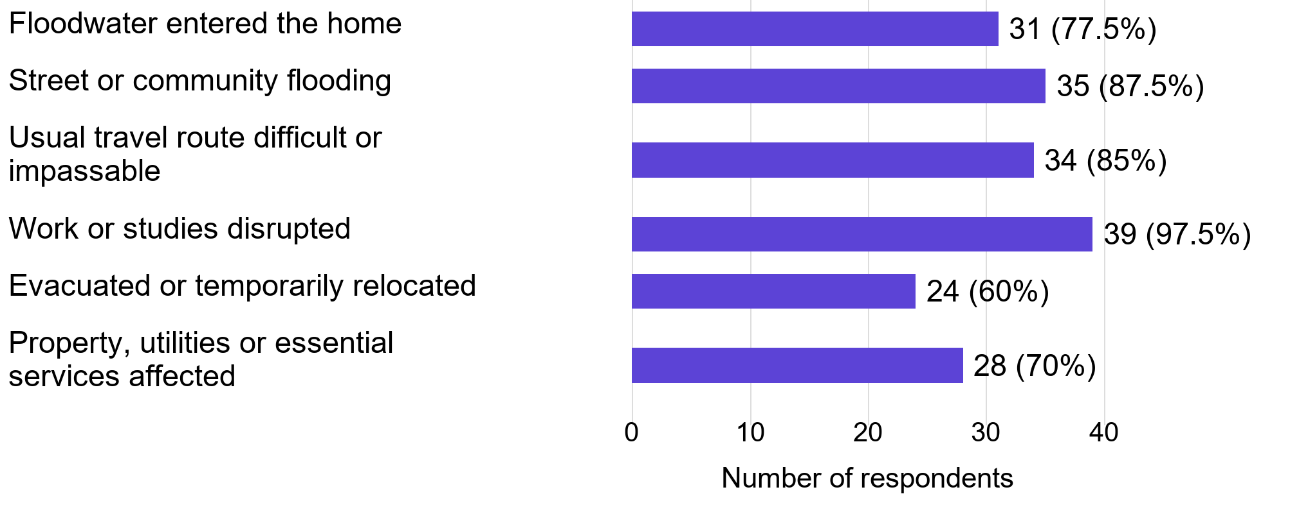
Figure 4. Reported effects of flooding and heavy rainfall (n = 40).
The item measured the effects respondents experienced during the three-year reference period. Work or study disruption was selected by 39 of 40 respondents (97.5%), street or community flooding by 35 (87.5%), and travel difficulty by 34 (85.0%). These are reported experiences, not independently measured flood impacts. Multiple selections were permitted; each percentage uses 40 respondents, so the percentages may exceed 100% in total.
Republic of the Philippines
CAVITE STATE UNIVERSITY
CvSU Bacoor City Campus
City of Bacoor, Cavite
(046) 476-5029
www.cvsu.edu.ph

DEPARTMENT OF COMPUTER STUDIES

Number of experienced events
Question 9. Approximately how many separate flood or heavy-rainfall events affected you within the past three years?
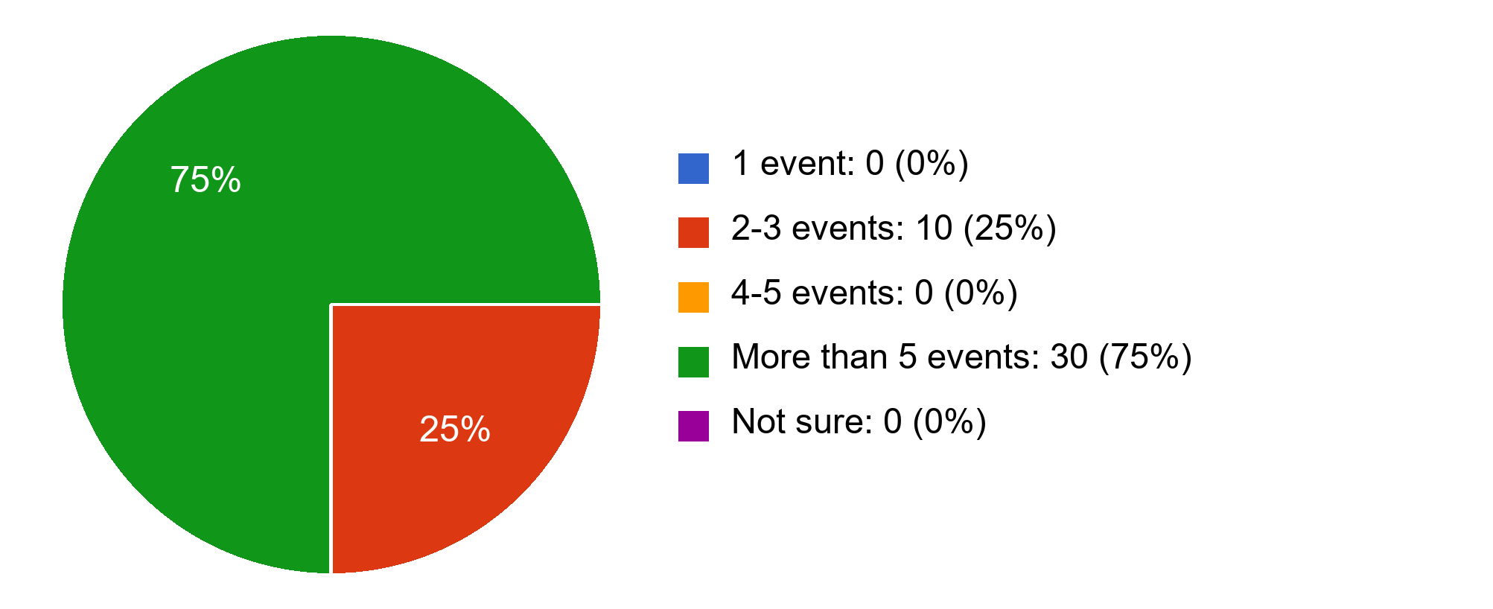
Figure 5. Number of experienced events (n = 40).
This single-response item asked respondents to estimate the number of separate flood or heavy-rainfall events affecting them within the past three years. Thirty of 40 respondents (75.0%) selected more than five events, while ten (25.0%) selected two to three. The responses describe recalled experience; they do not establish an official event count or flood-frequency estimate for Bacoor City.
Republic of the Philippines
CAVITE STATE UNIVERSITY
CvSU Bacoor City Campus
City of Bacoor, Cavite
(046) 476-5029
www.cvsu.edu.ph

DEPARTMENT OF COMPUTER STUDIES

Existing flood-information sources
Question 10. Where do you currently obtain flood or heavy-rainfall information? Select all that apply.
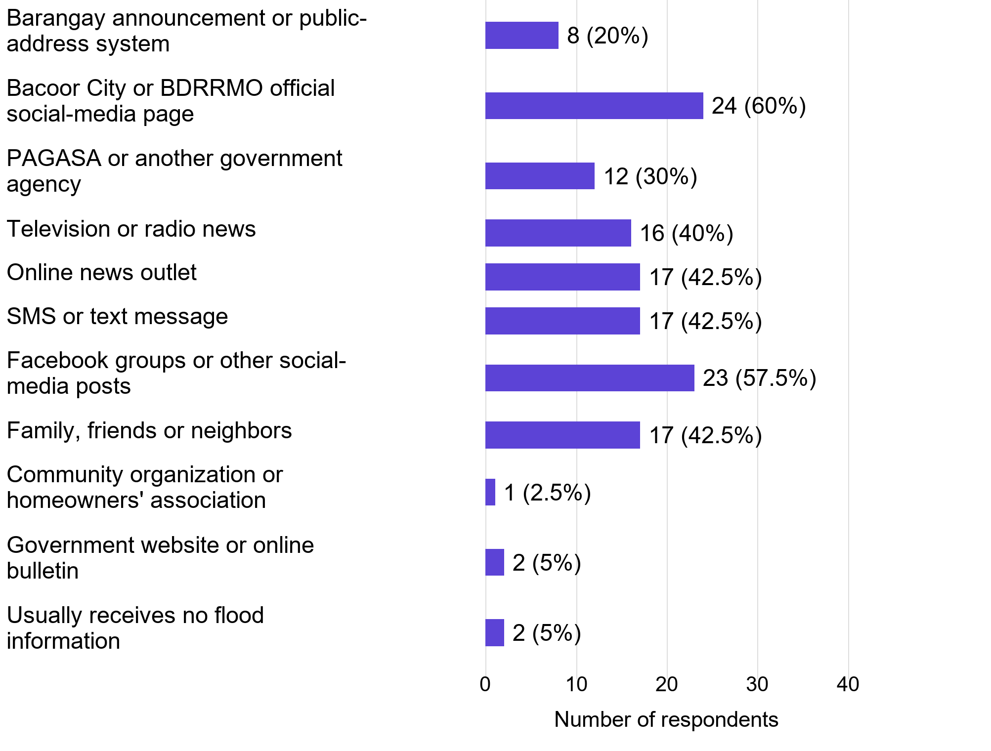
Figure 6. Existing flood-information sources (n = 40).
The item identified the channels respondents already used. Official Bacoor City or BDRRMO social-media pages were selected by 24 of 40 respondents (60.0%), and Facebook groups or other social-media posts by 23 (57.5%). Each checkbox percentage uses 40 respondents and totals may exceed 100%. One record combined receiving no information with named sources; its selections were retained as submitted. Use of these channels does not itself establish their accuracy or adequacy.
Republic of the Philippines
CAVITE STATE UNIVERSITY
CvSU Bacoor City Campus
City of Bacoor, Cavite
(046) 476-5029
www.cvsu.edu.ph

DEPARTMENT OF COMPUTER STUDIES

Difficulty obtaining needed flood information
Question 11. Overall, how easy or difficult is it for you to obtain the flood information you need?
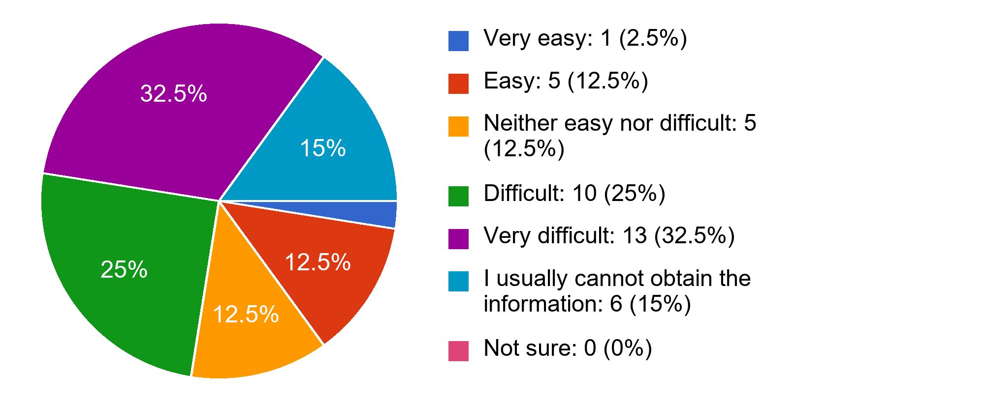
Figure 7. Difficulty obtaining needed flood information (n = 40).
This single-response item measured perceived access to needed flood information. Ten of 40 respondents (25.0%) selected difficult, 13 (32.5%) very difficult, and six (15.0%) usually could not obtain it. Together, these categories accounted for 29 respondents (72.5%). Six respondents (15.0%) selected easy or very easy. The distribution establishes an access concern within this sample, not a measured failure rate of any particular information service.
Republic of the Philippines
CAVITE STATE UNIVERSITY
CvSU Bacoor City Campus
City of Bacoor, Cavite
(046) 476-5029
www.cvsu.edu.ph

DEPARTMENT OF COMPUTER STUDIES

Frequency of existing information problems
Question 12. Based on your experience, how often do you encounter each problem with existing flood-information sources?
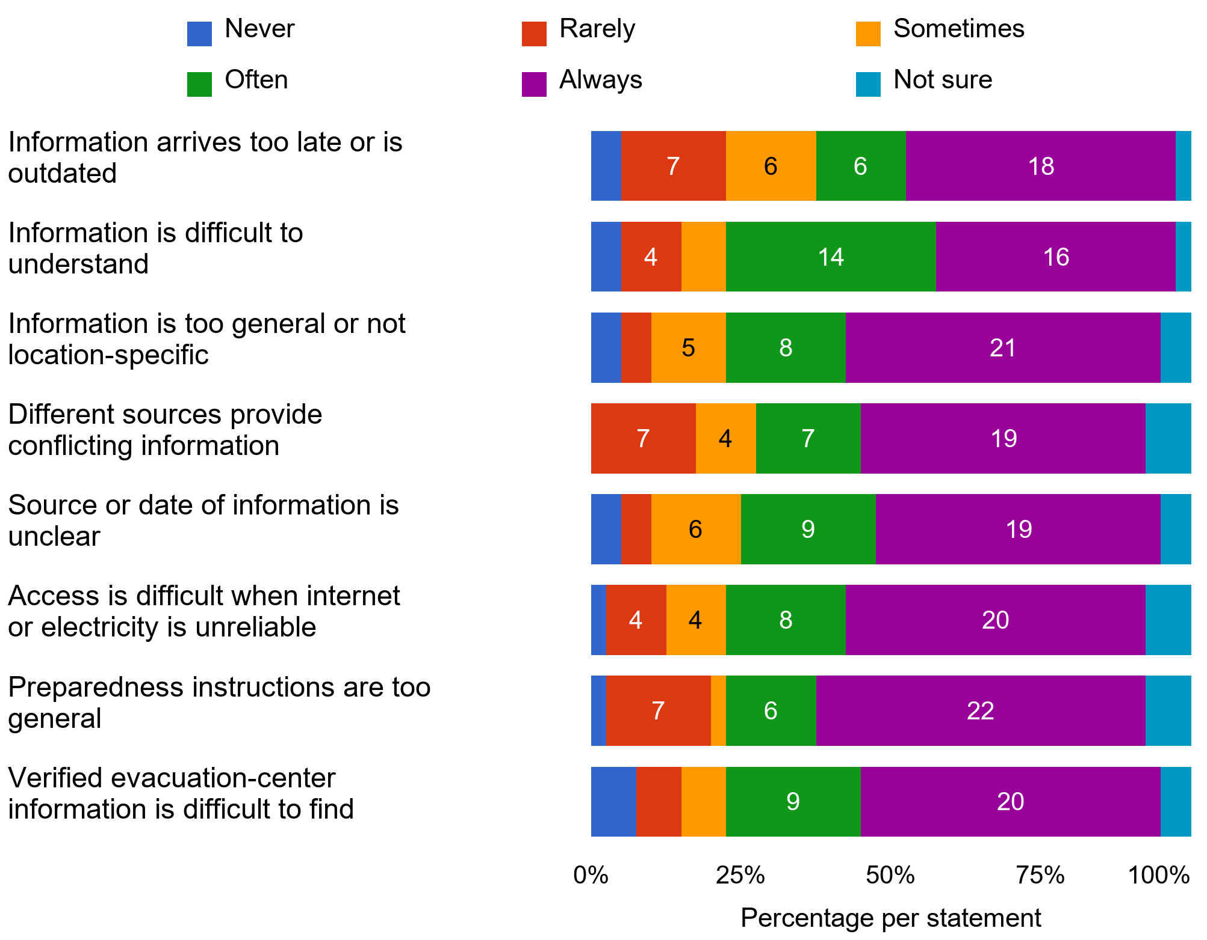
Figure 8. Frequency of existing information problems (n = 40).
This grid measured how often respondents encountered eight information problems. Often or always was selected by 30 of 40 respondents (75.0%) for difficult-to-understand information, 29 (72.5%) for information that was too general, and 28 (70.0%) for unclear source or date information. Each row has 40 single responses; segment labels show counts and bar lengths show percentages. Not sure remains a separate response category. The chart describes reported frequency, not application performance or verified causes.
Republic of the Philippines
CAVITE STATE UNIVERSITY
CvSU Bacoor City Campus
City of Bacoor, Cavite
(046) 476-5029
www.cvsu.edu.ph

DEPARTMENT OF COMPUTER STUDIES

Frequency of effects on decisions
Question 13. How often have late, unclear, incomplete, or conflicting flood information affected your decisions?
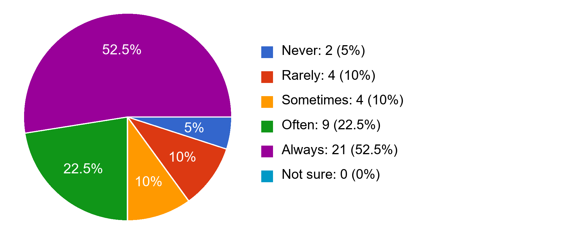
Figure 9. Frequency of effects on decisions (n = 40).
The item measured how often respondents believed inadequate flood information affected their decisions. Twenty-one of 40 respondents (52.5%) selected always and nine (22.5%) often, a combined 30 (75.0%). These single-response answers describe perceived decision difficulties. They do not establish that a specific source caused an adverse outcome or that FloodSense has improved decisions.
Republic of the Philippines
CAVITE STATE UNIVERSITY
CvSU Bacoor City Campus
City of Bacoor, Cavite
(046) 476-5029
www.cvsu.edu.ph

DEPARTMENT OF COMPUTER STUDIES

Decisions made difficult or uncertain
Question 14. Which decisions have become difficult, uncertain, or delayed because of insufficient flood information? Select all that apply.
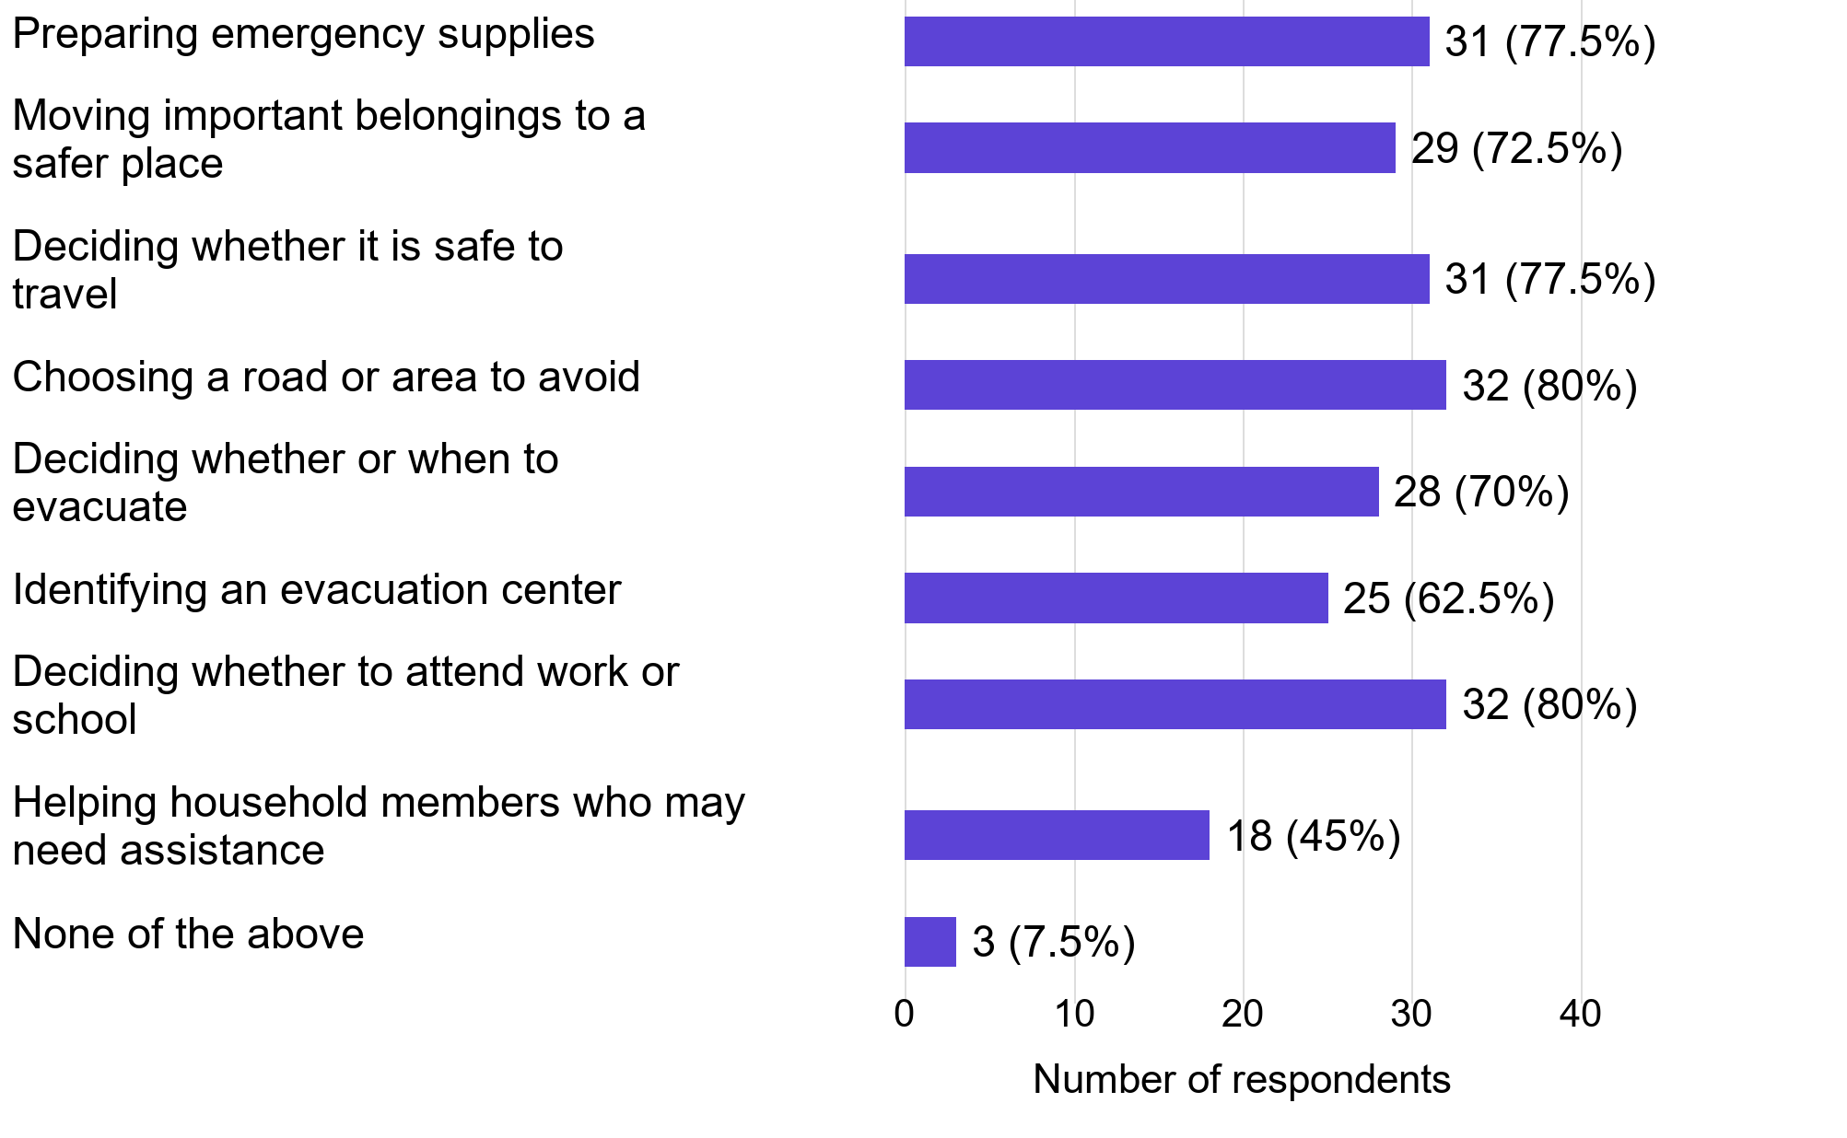
Figure 10. Decisions made difficult or uncertain (n = 40).
The checkbox item identified decisions respondents associated with insufficient flood information. Choosing roads or areas to avoid and deciding about work or school each received 32 selections (80.0% of 40). Each option uses all 40 respondents, and totals may exceed 100%. Two records combined none of the above with substantive choices; these combinations were retained and are internally inconsistent. Reported travel concerns do not establish a safe-routing capability for the proposed system.
Republic of the Philippines
CAVITE STATE UNIVERSITY
CvSU Bacoor City Campus
City of Bacoor, Cavite
(046) 476-5029
www.cvsu.edu.ph

DEPARTMENT OF COMPUTER STUDIES

Difficulty determining local susceptibility
Question 15. How difficult is it for you to determine whether your specific barangay or location may be susceptible to flooding before or during heavy rainfall?
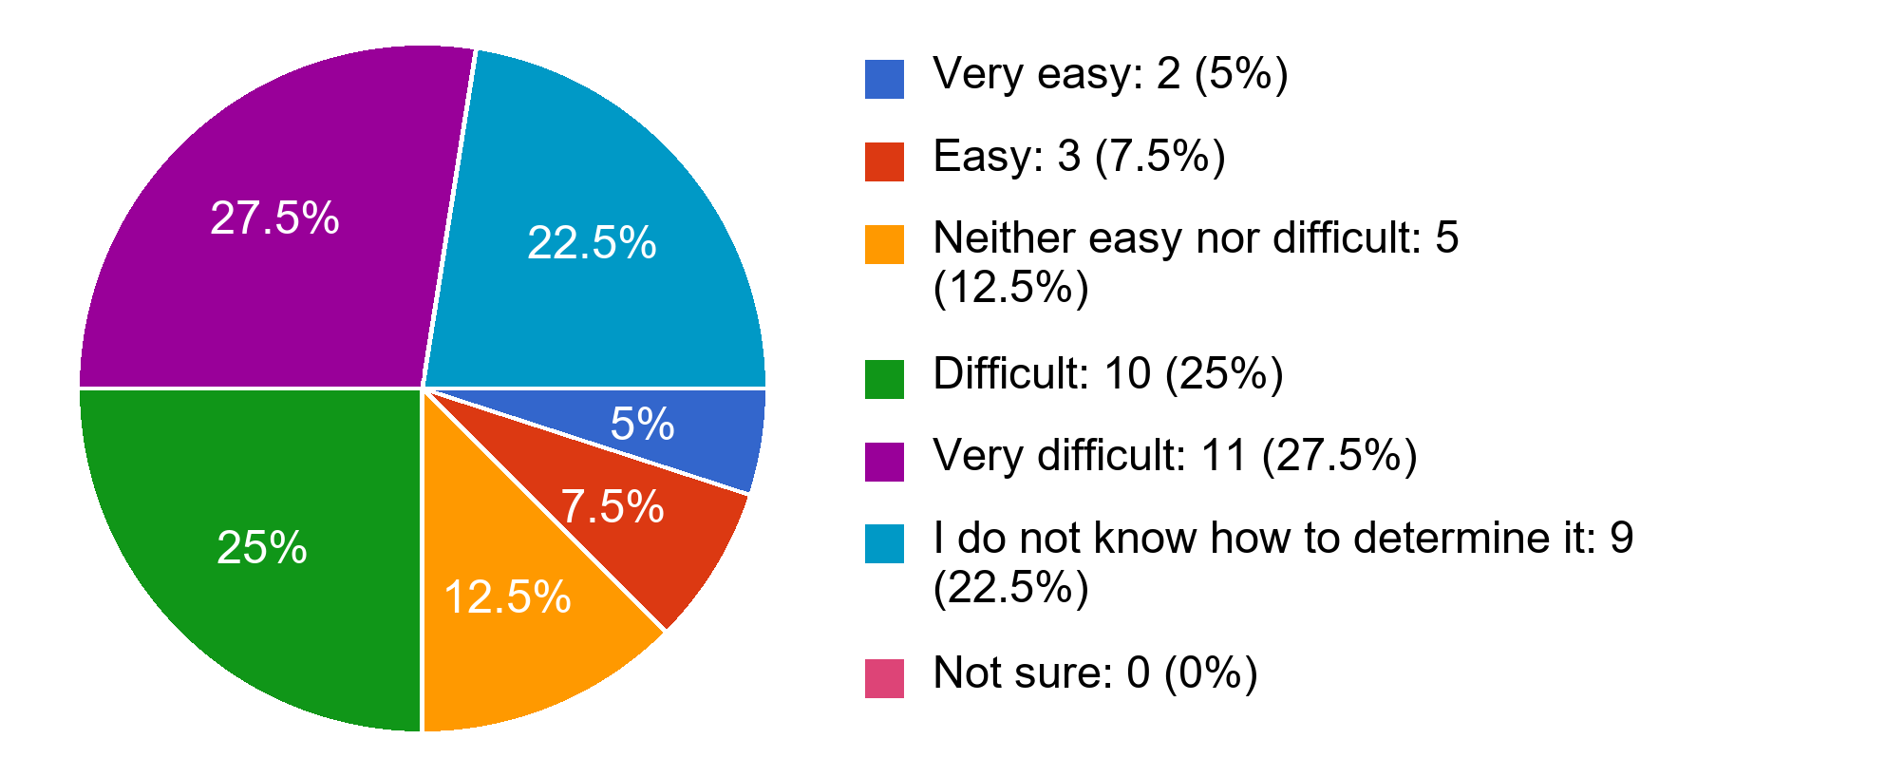
Figure 11. Difficulty determining local susceptibility (n = 40).
This single-response item addressed difficulty determining whether a specific barangay or location might be susceptible to flooding. Ten of 40 respondents (25.0%) selected difficult, 11 (27.5%) very difficult, and nine (22.5%) did not know how to determine it. Together, these categories comprised 30 respondents (75.0%). The result supports investigating understandable location-specific information; it does not validate susceptibility rules, maps, or classifications.
Republic of the Philippines
CAVITE STATE UNIVERSITY
CvSU Bacoor City Campus
City of Bacoor, Cavite
(046) 476-5029
www.cvsu.edu.ph

DEPARTMENT OF COMPUTER STUDIES

Access to verified evacuation-center information
Question 16. How easy or difficult is it for you to find verified evacuation-center information relevant to your location?
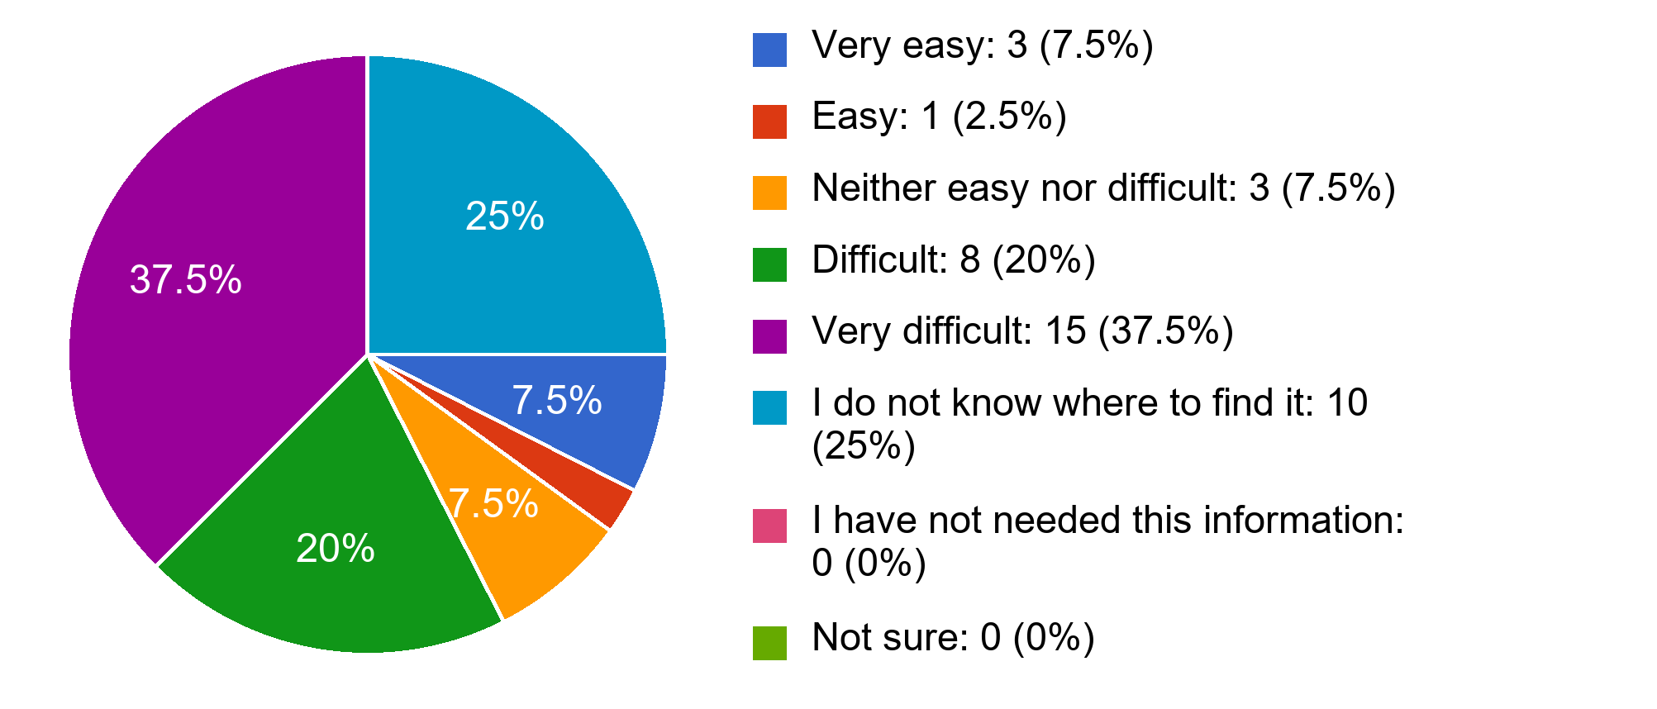
Figure 12. Access to verified evacuation-center information (n = 40).
This single-response item measured perceived difficulty finding verified evacuation-center information relevant to a respondent's location. Eight of 40 respondents (20.0%) selected difficult, 15 (37.5%) very difficult, and ten (25.0%) did not know where to find it. These categories total 33 respondents (82.5%). The finding concerns information access, not the verified operational condition, capacity, or availability of any evacuation center.
Republic of the Philippines
CAVITE STATE UNIVERSITY
CvSU Bacoor City Campus
City of Bacoor, Cavite
(046) 476-5029
www.cvsu.edu.ph

DEPARTMENT OF COMPUTER STUDIES

Priority information before possible flooding
Question 17. Which types of information are most important to you before possible flooding? Select up to three.
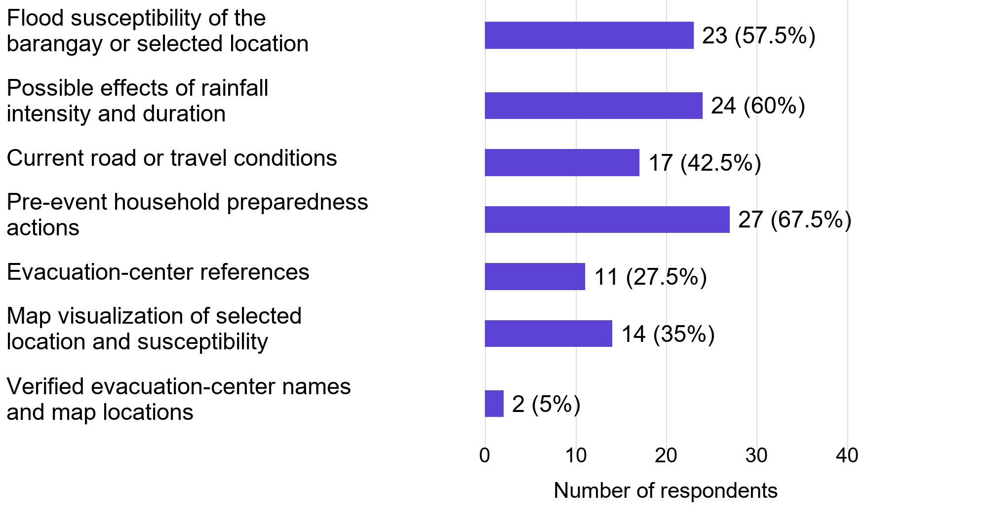
Figure 13. Priority information before possible flooding (n = 40).
Respondents could select up to three priority information types. Pre-event household preparedness actions received 27 selections (67.5% of 40), possible rainfall-intensity and duration effects 24 (60.0%), and local susceptibility 23 (57.5%). Each percentage uses all 40 respondents and totals may exceed 100%. Road or travel information was also requested, but that need does not mean the proposed system supplies live road conditions or safe routes.
Republic of the Philippines
CAVITE STATE UNIVERSITY
CvSU Bacoor City Campus
City of Bacoor, Cavite
(046) 476-5029
www.cvsu.edu.ph

DEPARTMENT OF COMPUTER STUDIES

Problems with existing preparedness guidance
Question 18. Based on the flood-preparedness advice you currently receive from barangay/LGU announcements, government agencies, news, or social media, what problems have you experienced? Select all that apply.
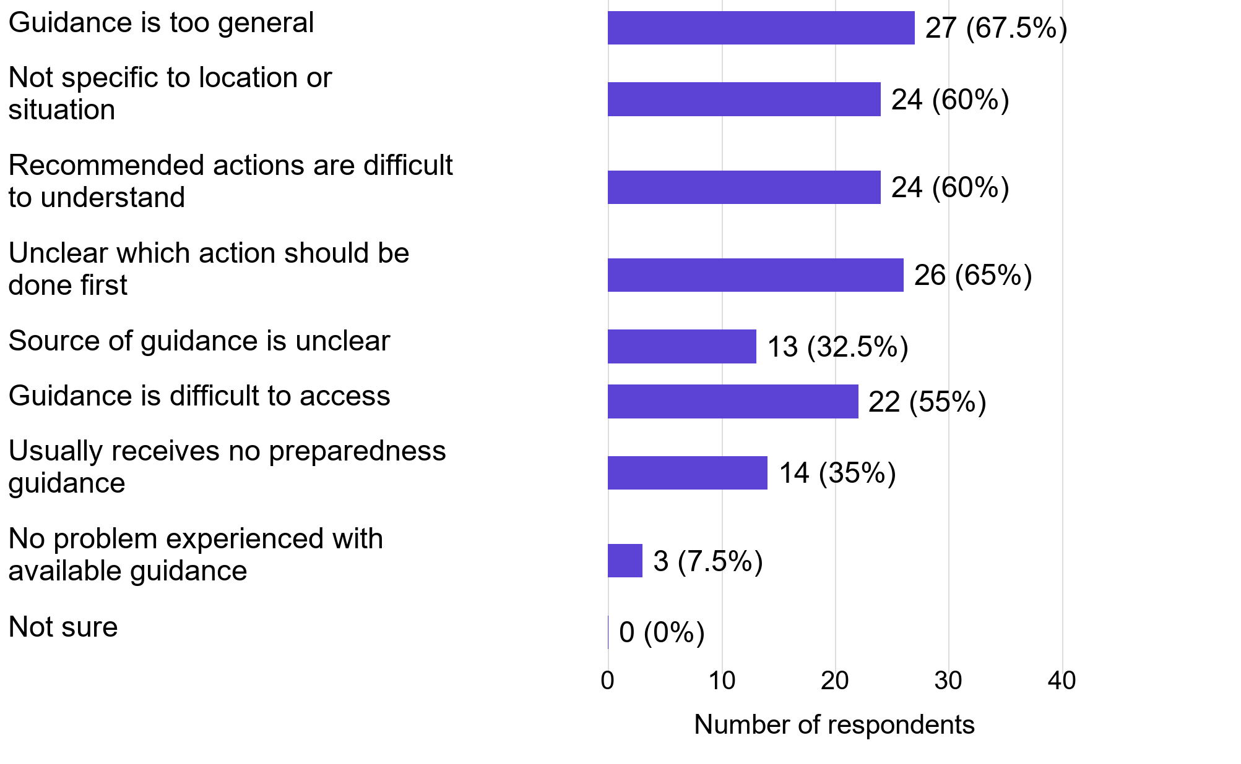
Figure 14. Problems with existing preparedness guidance (n = 40).
The item identified difficulties with preparedness advice from existing channels. Guidance was too general for 27 of 40 respondents (67.5%), while 26 (65.0%) reported uncertainty about which action should come first. Multiple selections were allowed, so each percentage uses 40 respondents and totals may exceed 100%. One record combined no experienced problem with another problem; it was retained. These are reported needs, not findings from using FloodSense.
Republic of the Philippines
CAVITE STATE UNIVERSITY
CvSU Bacoor City Campus
City of Bacoor, Cavite
(046) 476-5029
www.cvsu.edu.ph

DEPARTMENT OF COMPUTER STUDIES

Evacuation-center details considered useful
Question 19. Which evacuation-center details would be useful to you? Select all that apply.
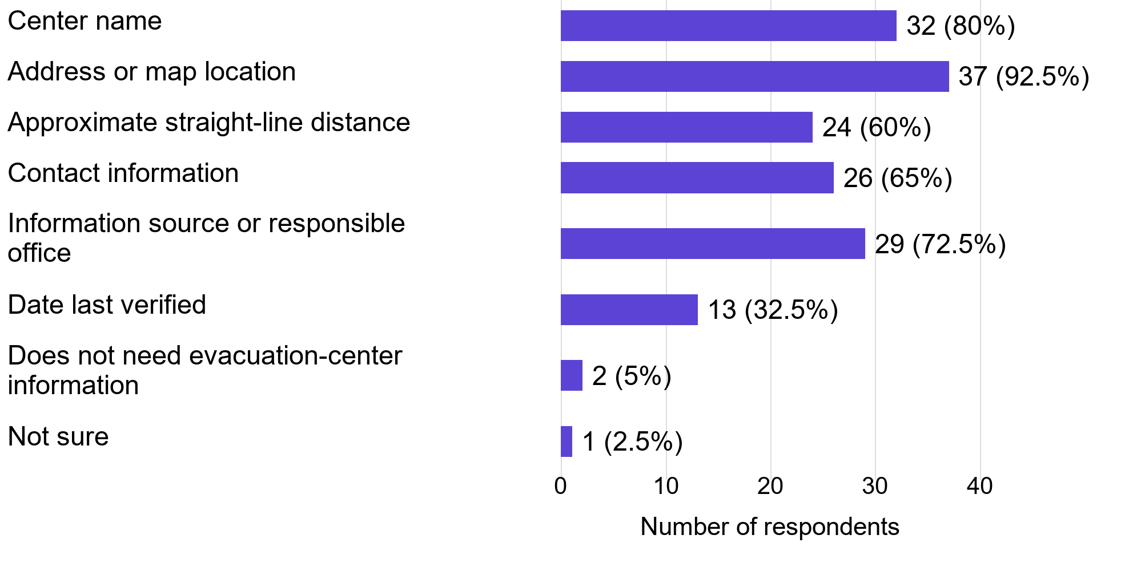
Figure 15. Evacuation-center details considered useful (n = 40).
The checkbox item asked which center details respondents would find useful. Address or map location received 37 selections (92.5% of 40), center name 32 (80.0%), and information source or responsible office 29 (72.5%). Percentages use all 40 respondents and may exceed 100% in total. Two records combined no need for center information with requested details; those selections were retained. Preferences do not verify an actual center's location, status, occupancy, or accessibility.
Republic of the Philippines
CAVITE STATE UNIVERSITY
CvSU Bacoor City Campus
City of Bacoor, Cavite
(046) 476-5029
www.cvsu.edu.ph

DEPARTMENT OF COMPUTER STUDIES

Access to Android smartphones
Question 20. Do you have regular access to an Android smartphone?
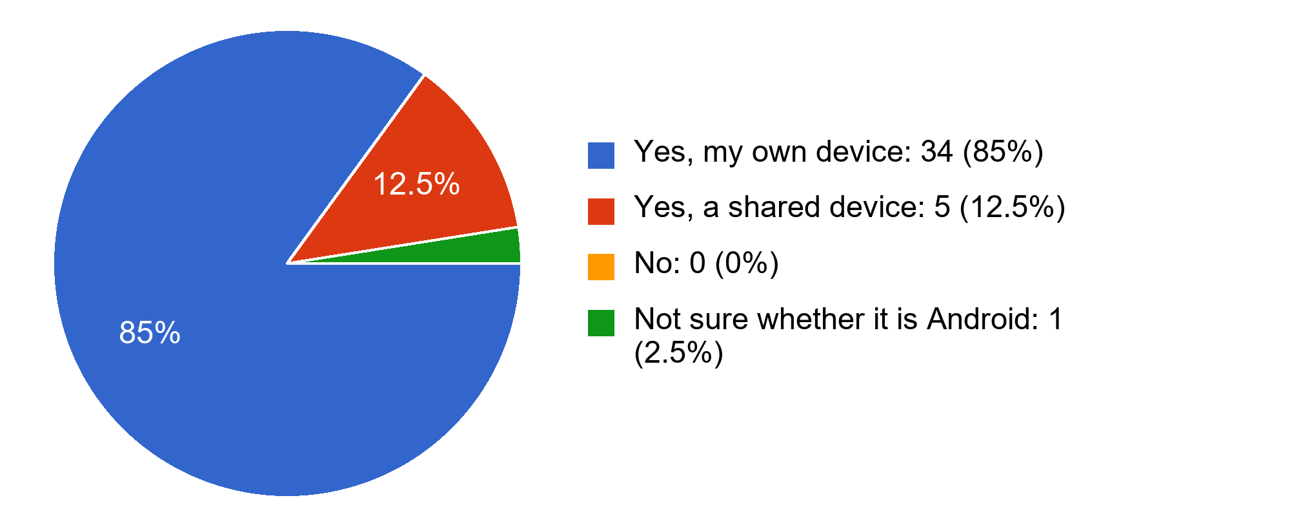
Figure 16. Access to Android smartphones (n = 40).
This single-response item measured regular access to an Android smartphone. Thirty-four of 40 respondents (85.0%) reported their own device and five (12.5%) a shared device, giving 39 (97.5%) with reported Android access. One respondent (2.5%) was unsure about the device platform. Access does not establish device compatibility, internet availability, willingness to install the application, or successful application use.
Republic of the Philippines
CAVITE STATE UNIVERSITY
CvSU Bacoor City Campus
City of Bacoor, Cavite
(046) 476-5029
www.cvsu.edu.ph

DEPARTMENT OF COMPUTER STUDIES

Internet reliability during heavy rainfall
Question 21. How reliable is your internet access during heavy rainfall?
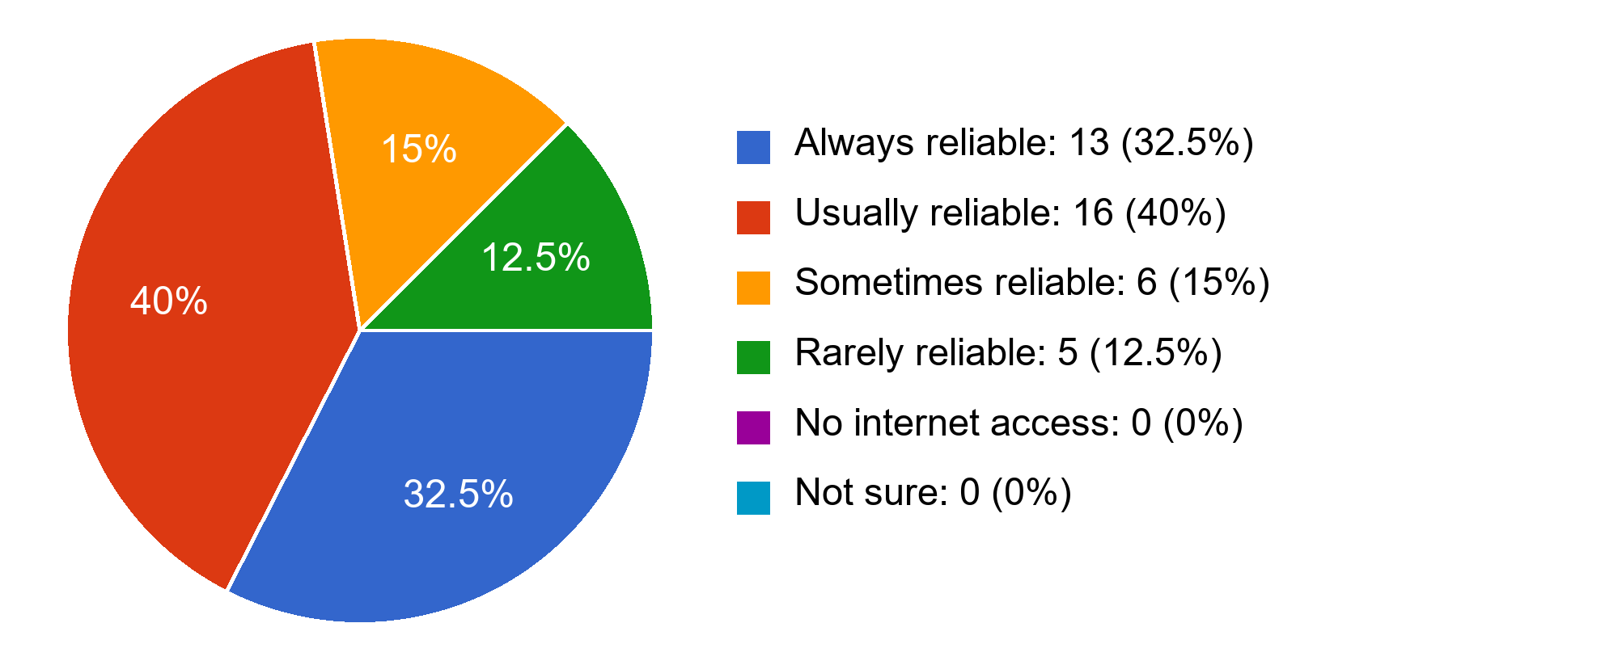
Figure 17. Internet reliability during heavy rainfall (n = 40).
This single-response item described perceived internet reliability during heavy rainfall. Thirteen of 40 respondents (32.5%) selected always reliable and 16 (40.0%) usually reliable. The remaining 11 (27.5%) selected sometimes or rarely reliable. These reports indicate varied access conditions within the sample; they do not constitute a network-performance test or establish offline operation of the proposed system.
Republic of the Philippines
CAVITE STATE UNIVERSITY
CvSU Bacoor City Campus
City of Bacoor, Cavite
(046) 476-5029
www.cvsu.edu.ph

DEPARTMENT OF COMPUTER STUDIES

Acceptable location-selection methods
Question 22. Which location-selection methods would you be willing to use in an application? Select all that apply.
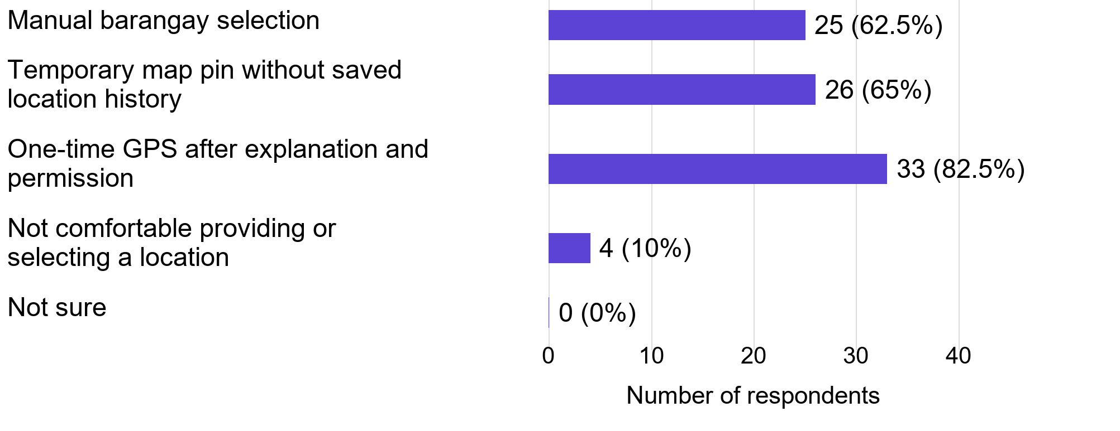
Figure 18. Acceptable location-selection methods (n = 40).
The item asked which location-selection methods respondents would be willing to use. One-time GPS after explanation and permission received 33 selections (82.5% of 40), a temporary map pin 26 (65.0%), and manual barangay selection 25 (62.5%). Each checkbox percentage uses 40 respondents and totals may exceed 100%. One record combined location discomfort with an accepted method. Stated willingness is not permission for background tracking or evidence of actual application acceptance.
Republic of the Philippines
CAVITE STATE UNIVERSITY
CvSU Bacoor City Campus
City of Bacoor, Cavite
(046) 476-5029
www.cvsu.edu.ph

DEPARTMENT OF COMPUTER STUDIES

Language presentation preference
Question 23. Which language presentation would be easiest for you to understand?
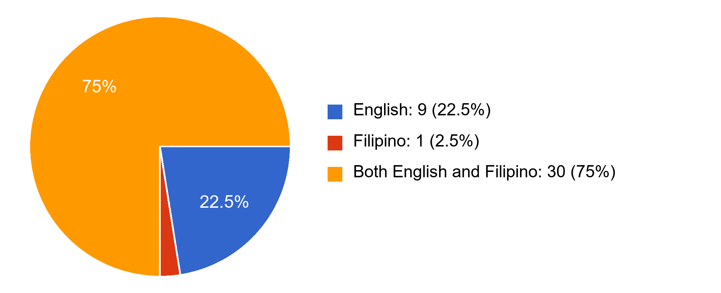
Figure 19. Language presentation preference (n = 40).
This single-response item measured which language presentation respondents expected to understand most easily. Thirty of 40 respondents (75.0%) preferred both English and Filipino, nine (22.5%) English, and one (2.5%) Filipino. The distribution supports considering bilingual presentation for this respondent group. It does not measure the readability or usability of an implemented interface.
Republic of the Philippines
CAVITE STATE UNIVERSITY
CvSU Bacoor City Campus
City of Bacoor, Cavite
(046) 476-5029
www.cvsu.edu.ph

DEPARTMENT OF COMPUTER STUDIES

Optional information requests
Question 24. What is the most important flood information or application function that you need but currently find difficult to obtain?
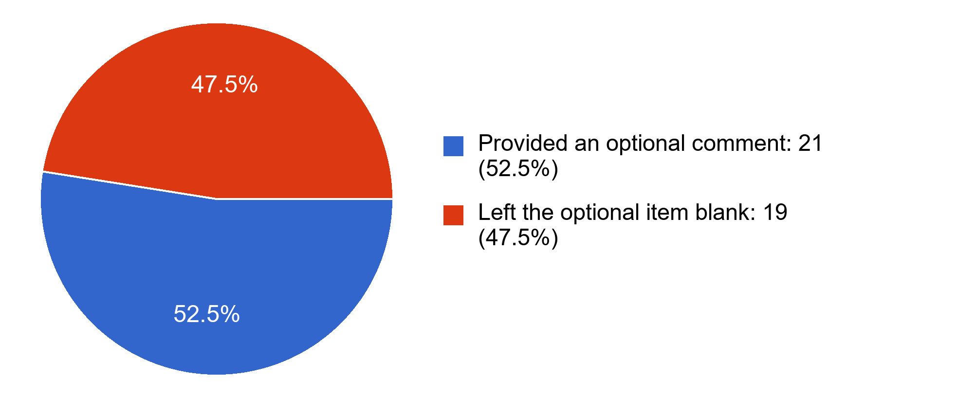
Figure 20. Optional information requests (n = 40).
Twenty-one of 40 respondents (52.5%) provided an optional comment and 19 (47.5%) left the item blank. The completed analysis identified requests concerning maps and location information, flood depth, warning or timing information, and evacuation-center references. Six comments repeated the same long recommendation; repeated wording was not treated as six distinct ideas. Requests for real-time information remain needs expressed by respondents, not implemented system functions. No names, initials, or individual comments are reproduced.
The response workbook and completed initial-survey report provide the basis for these descriptive results. An identical pair of substantive response records and a short timestamp cluster were retained because the available records did not establish whether they were independent submissions. No inferential conclusions or system-evaluation results are presented.

